Meet the Teacher

About Me

First of all, I am so happy we get to spend the year together! I’ve been teaching since 1992. This is my 8th year here at NMS. We’re going to have an AWESOME 7th grade year.

 

Mrs. Deal

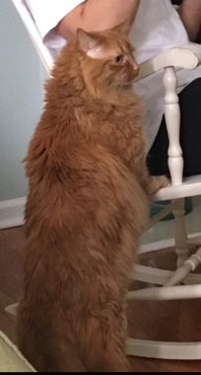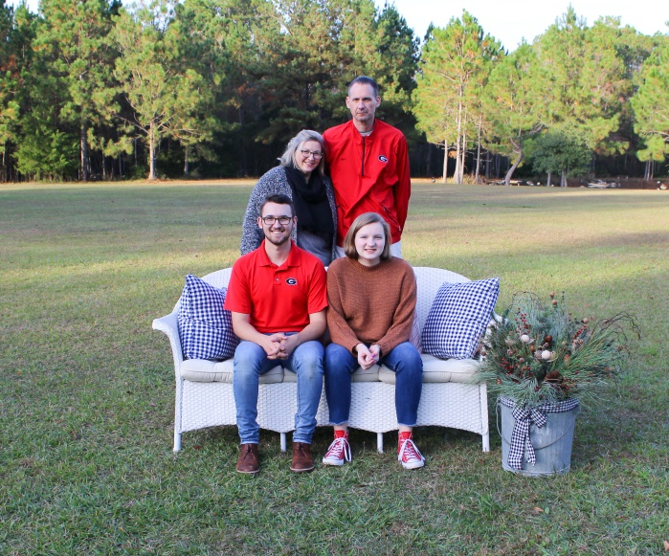

Home Town: None! I’m an ARMY brat, so I’m from everywhere.

College: Georgia Southern University

Pets: Hobbes-my big furry cat that sheds on everything.

Husband: Jay- Bridgestone/Firestone claims for the southeast.

Kids: Dillon-19 and off to college at Georgia Southern

Bea- sophomore at Milton

Hobbies: Photography, reading, binging Netflix



Color: Teal

Team: UGA Football, Atlanta Braves Baseball

Food: Zaxby’s Grilled Cob salad

Drink: Sweet tea from Dunkin, Zaxby’s, or Chick fil A

Game: UNO

Book: Gone with the Wind (and SO many more!)

T.V.: Stranger Things, The Goldbergs, Atlanta Braves Games

Movies: Anything Marvel

Shopping: Hobby Lobby, Target, Homegoods

Things I Don’t Like: Coffee (EW!), Talking while I’m talking, Bullies



Get in touch with me: [deal@fultonschools.org](mailto:deal@fultonschools.org)

Please visit my website on a regular basis. It is the best way for you to look at assignments. **Amydeal.weebly.com**.

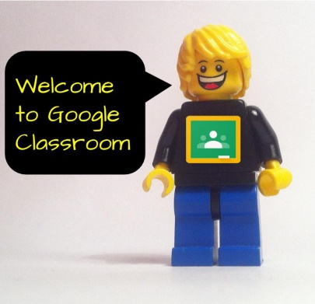Please look frequently at grades on infinite campus. Please don’t expect new grades every day.

Get access to Google Classroom from your child. You can see all assignments there.

Please feel free to request a conference at any time of the year. Mornings are best for me.



**Looking forward to working with you and your children this year!**